worksheet 3: Body part counting in New Guinea
Resources: Worksheet 3
Focus on content: numbers and body parts
Focus on languages: written comprehension; oral production 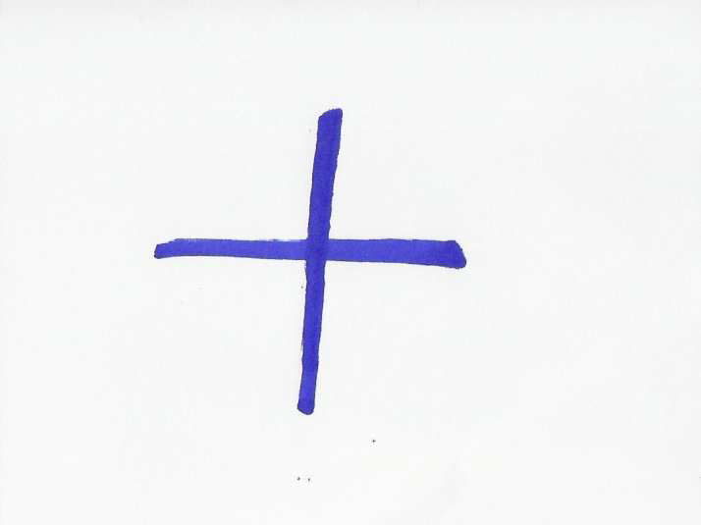
Timing: 20 minutes
Grouping: 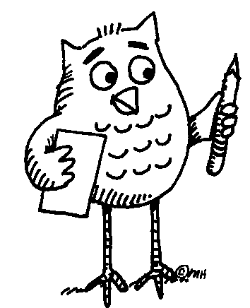 ( ... ) Learners work in pairs. Later they compare their results with the others in class.

Learner worksheet 3: BODY PART COUNTING IN NEW GUINEA



Task 1: Read the paragraph using the dictionary to clarify the meaning of unknown words or phrases. Find New Guinea on the map.
Nowhere in the world is the diversity of cultures and languages so marked as on the island of New Guinea. The number systems reflect this diversity. Saxe (1982) in Joseph (2000) describes the counting system of a province in Papua New Guinea in the following terms: starting with the thumb of a hand, counting proceeds along the fingers of that hand, so that 7 is the forearm along the upper periphery of the body, to the face, with 12 being the nearest ear to the hand that has been counted, to the nearest eye -13, the nose -14, the other eye -15, the other ear -16 and down along the other side of the body to the little finger on the other hand -27. Such a system of number representation has been used to describe a range of diverse activities, whether counting a set of objects, measuring the length of an object, or establishing the location of a house in relation to other houses on a path.
Adapted from: Joseph, G.G. The Crest of the Peacock, London: Penguin Books Ltd., 2000.
Task 2: Speculate which parts of the body represent numbers that are not mentioned in the text. You can speak in English or your mother tongue. After you agree, try to write the body parts in the two languages below.
6 20
8 21
9 22
10 23
11 24
17 25
18 26
19
Notes for the teacher: Worksheet 3
Task 2 – Answer sheet: It was not possible to find the correct answers. Therefore, the activity is meant as language practice. Learners revise vocabulary for body parts. While talking to each other in pairs, they can also practice grammar – ways of expressing modality (“It may / must / could be …, it can’t be …”).
Additional information:
- Playing different musical instruments means the use of different of numbering for fingers. The teacher can elicit the following:
Piano: thumb-1, index finger-2, middle finger-3, ring finger-4, little finger-5
Violin: ----------, index finger-1, middle finger-2, ring finger-3, little finger-4
Flute: thumb-0, index finger-1, middle finger-2, ring finger-3, little finger-4
- Manual alphabets are used by a number of deaf communities all over the world. The first book on deaf education was written by Juan Pablo Bonet, a Spanish monk, in 1620 but the earliest documents date back to 15th and 16th century.
References:
Joseph, G.G. The Crest of the Peacock, London: Penguin Books Ltd., 2000.
Longman Dictionary of Contemporary English, 1990.

